J09 Valentine Series

J09A Sepia monochrome cards

Pu Valentine & Sons Publishing Co.
Pr In Great Britain
F Glossy photographic print with title in italic lettering superimposed on view; Each card has a number preceded by the letters 'n.g.' and we use these numbers as part of our own catalogue number. All have V2 back.

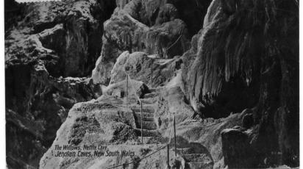

J09A.30 The Willows, Nettle Cave,/Jenolan Caves, New South Wales H
J09A.31 The Grand Arch/Jenolan Caves, New South Wales H (We have one example with a matt finish)
J09A.32 Grand Stalagmite, River Cave,/Jenolan Caves, New South Wales V
(This negative was photographed using the same camera position as Kerry's 01.5, which is titled by the present-day name of "The Grand Column", but the two negatives have different lighting and are apparently the result of two successive exposures. This one is attributed in Trickett's Guide to Jenolan to Trickett himself. We assume that this attribution is correct and that the two friends worked together.)
J09A.33 The Minaret, River Cave,/Jenolan Caves, New South Wales V (s.n.a. 00.14)
J09A.J6 Nettle Cave, Jenolan Caves, New South Wales V
J09A.35 Gem of the South, Temple of Baal/Jenolan Caves, New South Wales H [ms.Jan.1923]
J09A.36 Underground River,/Jenolan Caves, New South Wales H
(This shows the same punt, located in the same position, carrying the same people, who are wearing the same clothes as in Kerry's 16.2. The difference is that the people have exchanged seats within the punt and are now seated in a slightly different sequence. One must assume that both photographs were taken on the same occasion. Again, we have one example with a matt finish.)

J09B. Coloured cards [n.l. 1915]

As above from same negatives, but cards in colour.
J09B.30 The Willows, Nettle Cave,/Jenolan Caves, New South Wales H
J09B.31 The Grand Arch,/Jenolan Caves, New South Wales H
J09B.32 Grand Stalagmite, River Cave,/Jenolan Caves, New South Wales V
J09B.33 The Minaret, River Cave,/Jenolan Caves, New South Wales V
J09B.J6 Nettle Cave, Jenolan Caves, New South Wales V [ms.13 Sep.1915]
J09B.35 Gem of the South, Temple of Baal/Jenolan Caves, New South Wales H [ms.Jan.1923]
J09B.36 Underground River,/Jenolan Caves, New South Wales H [ms.30 Apr.1918]

We also have the views used in series J09 above (together with a view of the Rodriquez Pass at Blackheath) in a Jenolan Caves Souvenir Folder and this suggests that the series is complete at 7 cards.

